RUGS ETC FOR SALE – ALL CLEAN £20 - £25 (some hardly used)
L/W = lightweight; M/W = middle weight; H/W = heavyweight; T/O = turn out
Please speak or text Lyn 07970784206 – all here on my lorry.

5 – 9 6ft
M/W T/O with neck L/W T/O
Under rug
Fly sheet 6ft 3
Fly sheet Fly sheet
L/W stable with neck M/W stable
M/W stable with neck
H/W stable 4ft 3
L/W T/O
5-6
M/W stable with neck Large foal – adjustable rug
L/W stable with neck
M/W stable with neck 3 Eskadron Control Headcollars
M/W stable (cob/horse) - £10
M/W stable
5-6/9 4 pony headcollars – 2 unused - £5
Matching green sheets x2 - £15 each
5-3 Selection of bits driving and riding
M/W stable see below photographs £10-£25
5-3/6
M/W stable
M/W stable
Fly sheet
M/W stable
L/W T/O

5.25 inches 130 cm

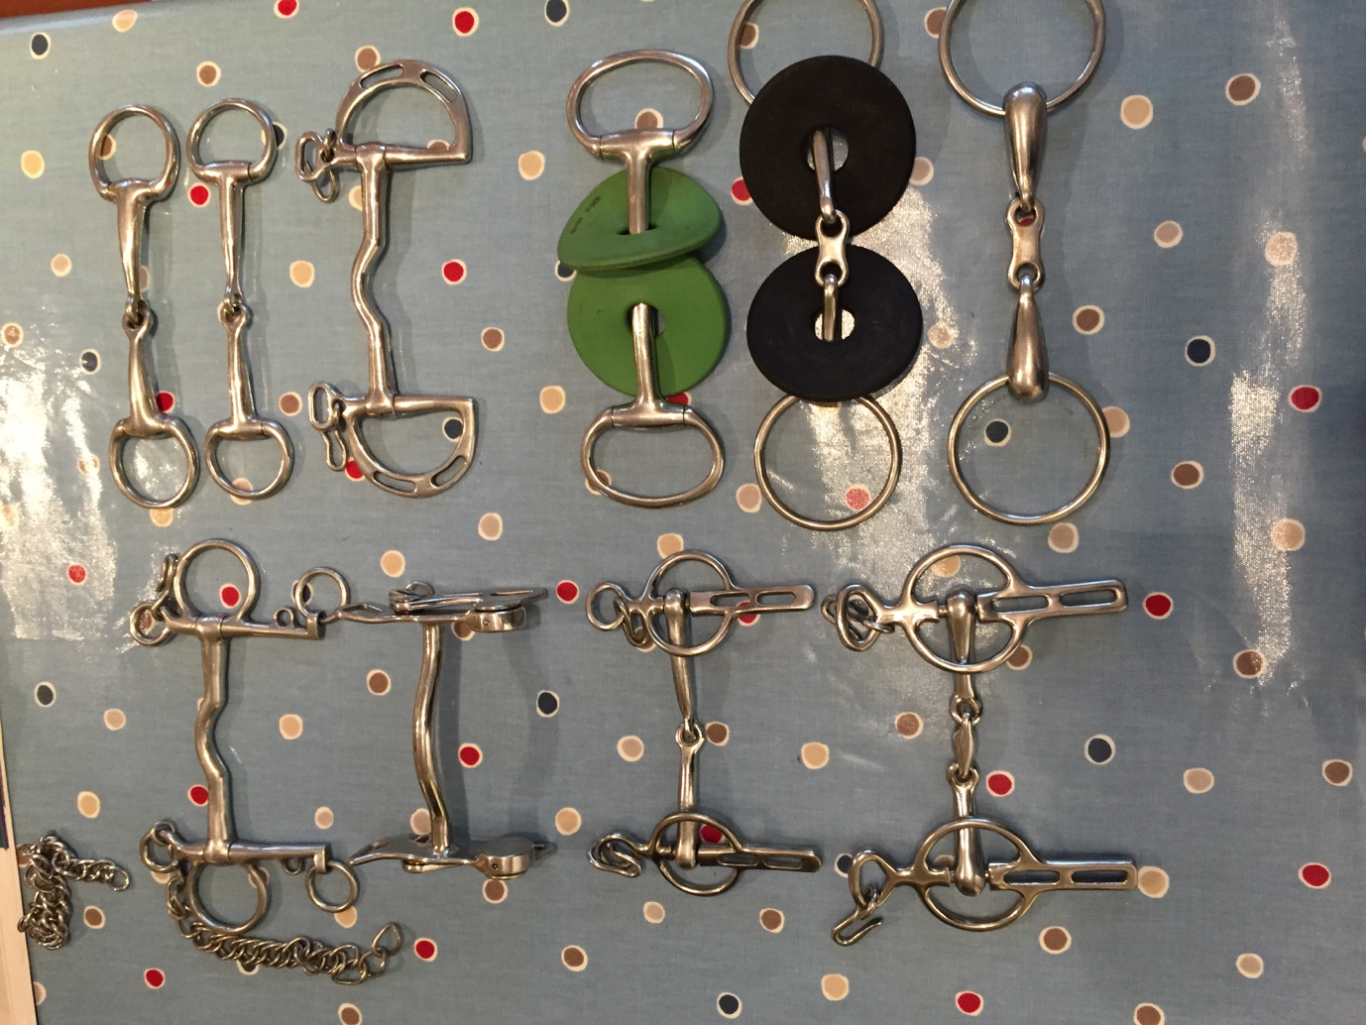

5.5 inches 135 cm

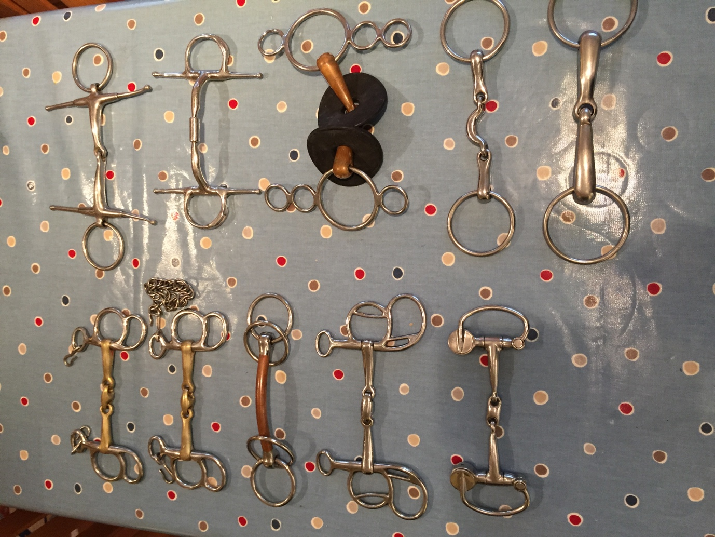

6 inches 140cm

