Welsh Section D Gelding 4yo

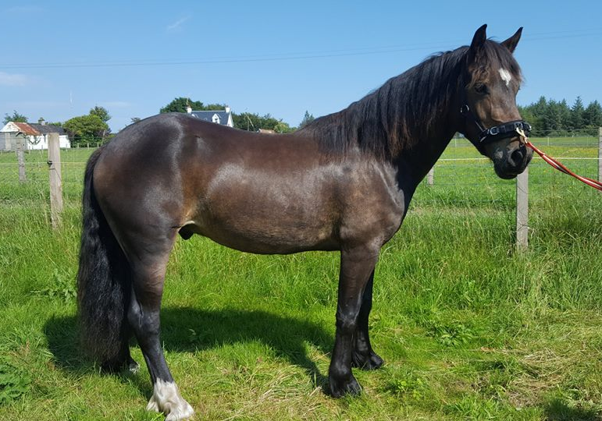
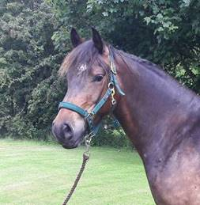

Handsome 4yo gelding
From good performance bloodlines, standing 14 hh.
Good straight mover, 3 nice paces, lunges in nice outline, recently started longreining.
Family commitment forces us to sadly have to part with him.
A good home is more important than price. He needs a new home where he can continue his training with someone who is experienced with youngsters.
Good feet, regularly trimmed, vaccs up to date, loads well, used to a bit of traffic, enjoys a paddle in the sea!

Can currently be viewed at Wardhouse Equestrian in Johnstone/Renfrewshire area, where he has recently had professional training. Might be moving him shortly.
Please get in touch for more info: 07598 999175

