28 June 2014

Dear Competitor,

thank you for joining us at Sandringham on 28--29 June, by gracious permission of Her Majesty the Queen.

Entry to the event is the same for all national, international and EACDG competitors – through the West Newton Gate, which will be signposted.

Attached are the dressage, marathon times, maps and numbers for our event. Please complete the coloured form and place it in your vehicle windscreen. Check your own time, dressage test and class: if you have a query, please contact us immediately –07855451413, text or phone.
Things do change, however well we plan, so keep checking our noticeboards at the event for news.

We are driving obstacles 1 to 5 and 8 you can walk them Thursday and Friday, subject to them being open, and on Saturday evening and Sunday morning. You may not bring your horse or pony on site until 12pm on Friday, by strict order of the Sandringham Estate (unless you are helping or have arranged it with us).

Stable mats are not compulsory in our area. If you use electric fencing, please do so with consideration for others as we will otherwise be short of space. Jack in a Box has a trade stand in the national stable field in case you have forgotten anything or need a shopping experience. Kate’s Kitchen is providing catering.

There will be a muck heap – please don’t put string, baler twine or other rubbish in it. Ask us for a bin bag for your domestic rubbish if you need one and help us to keep down costs by taking it home.

Novice and prenovice classes: you must have a harness check before driving your dressage test. You are advised to have the check and allow time (30 minutes) to make any necessary recommended adjustments before your start. The check will take place in the collecting area near arena 2. Everyone has a check before their marathon start.

Late arrivals - you may walk the cones at lunchtime, subject to the permission of the cones arena officials.

On Saturday evening the technical briefing, 6:30pm, will be followed by presentation of the dressage rosettes and King of the Cones award,

EACDG yearbooks are available for everyone from the secretary. Get one if you haven’t already!

Please bring a gift for the stewards: anything that will make a volunteer feel appreciated. There will be a box for gifts near the noticeboard or at the Secretary’s lorry/tent.

Have fun… and if you have any comments or ideas about the event, please let us know.

lorna
Lorna Ingram eacdg secretary 07855451413

This event is organised by EACDG Ltd. with thanks to all our volunteers
Dressage Judges: Arena 1: Heather Turner Natalie Smith , Penny Wear, Liz Mills , s, Arena 2:, Rachel Gallyon, Danielle Twitchen, Mark Mills
National Course Designer: Barry Hunter Cones Designer: Fiona Powell
TD: David Watts with assistance from Dan Twitchen,
Scorers: Annette Bond, ,
Safety Officer: Lyn Price Harness check: Caronne Daft /Liz Harcombe , Penny Wear
Event Secretary: Lorna Ingram With lots of help from Zoe Morgan of Ashfields, ,
Dressage paperwork: Liz Harcombe : :
Stewards’ boxes: Diana Irwin Sponsored rosettes:Andrew Masters Stewards’ gifts: Lorna Ingram

Chief Steward:Ginny White–07776181035 more helpers? Bring them! Call Find us on Facebook

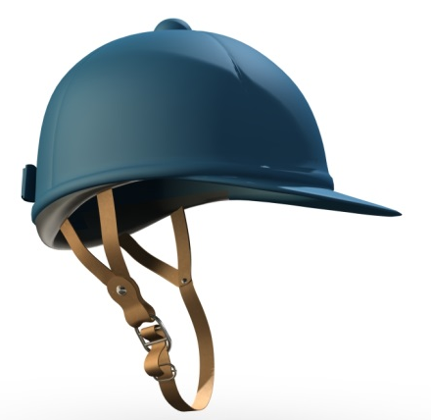
You can help us – keep your head and make this a successful and safe event by remembering to wear a helmet – fastened – when you are exercising your horse, on the carriage or riding, and when you are on a quad bike or motorbike.

Your safety is very important and you can help us by setting an example to others. Thank you!
 (Doh - now you are just being silly…)

STOP PRESS! PRIZES!
Cash prize – Zoe Napier Country & Equestrian offers a jewelled crown award and £25 cash for the King or Queen of the cones – clear round + fastest time under your class time is the winner – anyone could win!
£25 voucher to spend at Chandelles Saddlery; a carriage seat cover from Essjay Designs;a basket of all-natural healing balms from Botanica; Jack-in-a-box prizes of £10 vouchers for combined prenovice class and novice horse and pony drivers – and a small pony class prize from Louise Towers plus a years’ subscription to Inharness magazine.

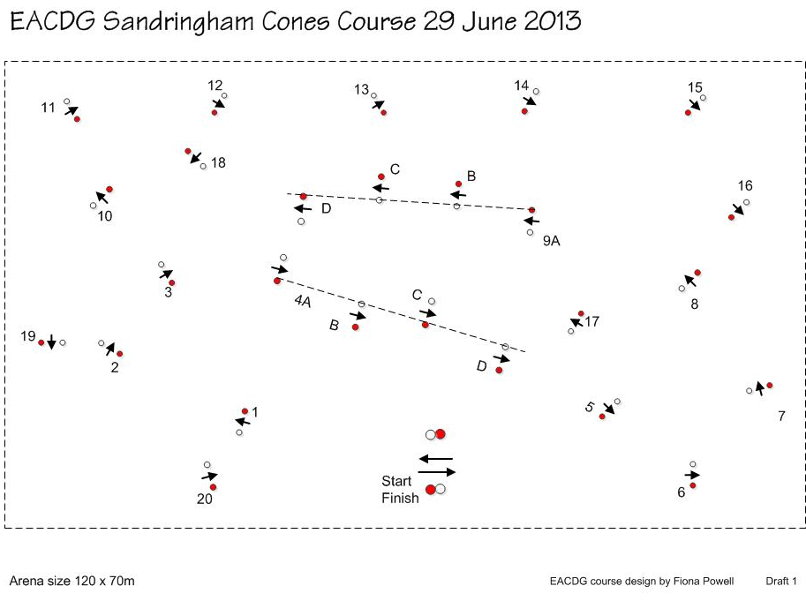

Obstacle diagrams
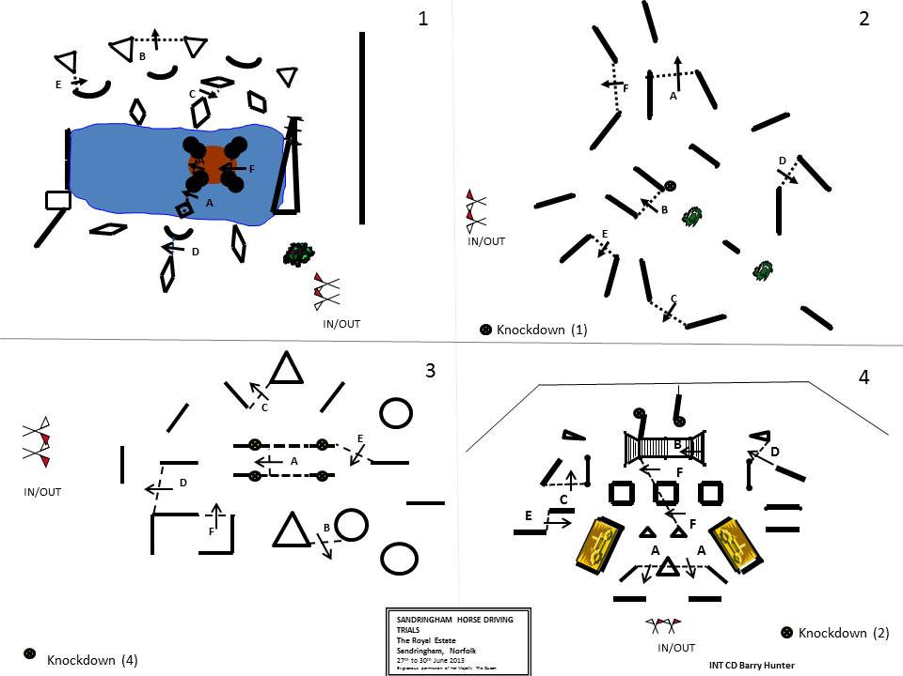

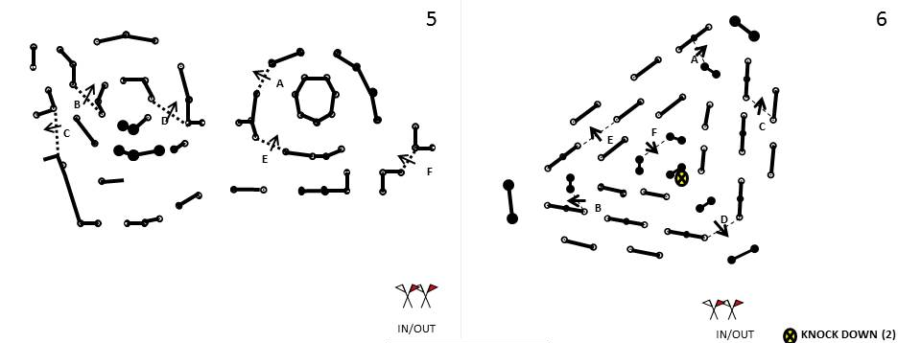

Marathon map – schematic of section E and map of sections A and transfer