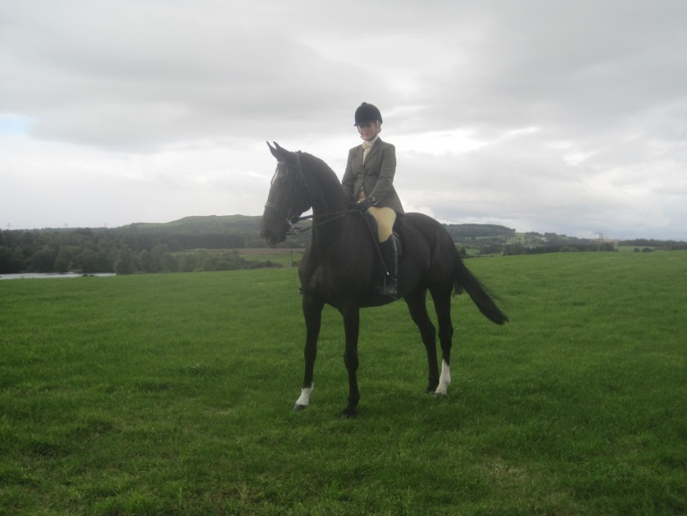

BEAUTIFUL BLACK MARE. ALL ROUNDER.
16.1 HH
17 Years old
Great Grandsire Voltaire.

Just broken to drive and going nicely. Can be sold with harness and beautiful Bennington BX4 carriage as a package
Fergusson Jessika : £2500
Bennington BX4 : £5500.00
Harness : £600.00

Her past:-
Competed BRC championships dressage and show jumping teams. Elementary / Medium Dressage. Riding Horse & Working Hunter Classes – won too numerous to list.
Pony Club Eventing / dressage teams.
Competed x Country by current owners + Working Hunter classes.
An excellent all round fun competition horse or ready to take dressage rider / driver to next levels.
Moves beautifully.
Safe to hack, shoe, box etc.

T: 07977 414697
E: amanda@west-gogar.com

